**Monarch Modelling Parameters**

*September 30, 2015*

The model consists of individual simulated Monarchs moving around a GIS landscape and laying eggs. Model inputs include the parameters and number of individual Monarchs. Model output is total number of eggs laid (and I’m pretty sure the number of eggs laid per habitat type).

Model has 3 major parts: *GIS landscape model*, *movement model*, and *egg-laying model.*

|  |  |  |
| --- | --- | --- |
| **Parameter** | **Values** | **Sources** |
| *Movement Model Parameters* | | |
| Perception Distance | 5 to 25 m | Zalucki and Kitching (1982b) |
| Field of View | ±30° to ±120° | n/a |
| Directionality | 0.2 to 0.8 | Zalucki and Kitching (1982b) |
| Step Length | 50 m to 125 m | n/a |
| Daily distance max | 15,000 m | Zalucki and Kitching (1985) (correct year is 1984) |
| *Egg-laying Model Parameters* | | |
| Max eggs laid per day | 100 | Based on 14-day lifespan with 1400 total eggs (Zalucki 1981) |
| Adult Lifespan | 14 days | Zalucki (1981), Zalucki et al. (1986) |
| Egg-laying rate | 1 egg per 2.5 m | Zalucki and Kitching (1982a,b) – 25 plants assumed to occur per 2.5 m, and 1 egg per 25 plants = 1 egg per 2.5 m -> 20 eggs in a 50m step, 50 eggs in a 125m step |
| *GIS Landscape Model Parameters* | | |
| Preference Value | 0-1 (or 0.1-1) | Model compares preference value of current habitat patch to nearby habitat patch to calculate probability of leaving current patch |

**GIS Landscape Habitat Categories**

|  |  |
| --- | --- |
| **Habitat Type** | **Preference Value** |
| Glyphosate Corn (88%) | ? |
| Non-Glyphosate Corn (12%) |  |
| Glyphosate Soybean (96%) |  |
| Non-Glyphosate Soybean (4%) |  |
| Forest |  |
| Road ROW MW=0 (16%) |  |
| Road ROW MW=1-40 sq m (72%) |  |
| Road ROW MW=41-100 sq m (13%) |  |
| Railroad ROW |  |
| Med/High Intensity Development | 0 |
| Low Intensity/Open Space Dev URBAN |  |
| Low Intensity/Open Space Dev EXURBAN |  |
| Water/Barren/Other |  |
| Grass/Pasture |  |
| Grass/Pasture PADUS |  |
| Wetlands |  |
| Riparian Buffers/other NRS TBD |  |
| Bioreactors |  |
| Utility ROW |  |
| CRP (subcategories TBD) |  |

Each category needs a preference value – think of this in terms of the probability it will leave the current habitat for another type of habitat.

Probability of leaving current patch = preference value of new patch/(preference value new patch + preference value of current patch) = $P\left(leave\right)= \frac{{Pref}_{B}}{{Pref}_{B}+{Pref}_{A}}$

Distance moved per day declines over time according to: Dist = -1076t + 16077

This means that the monarch moves 15,000 m the first day, ~14000 m the next day, and so on, losing ~1000 m per day, until it travels only 1000 m on the 14th and final day of its short life.

Correlated Random Walk – correlated with current direction by randomly choosing a change in direction for the current heading – apparently a new heading is calculated for each step

The change in heading is calculated in radians as: $θ=±πR(1-D)$ where D is directionality and R is a random number between 0 and 1.

A directionality of 0.2 (low directionality) means at each step the heading can change from 0 to 144 degrees right or left with any value in that range being equally likely (uniformly distributed).

A directionality of 0.8 (high directionality) means at each step the heading can change from 0 to 36 degrees right or left with any value in that range being equally likely (uniformly distributed).

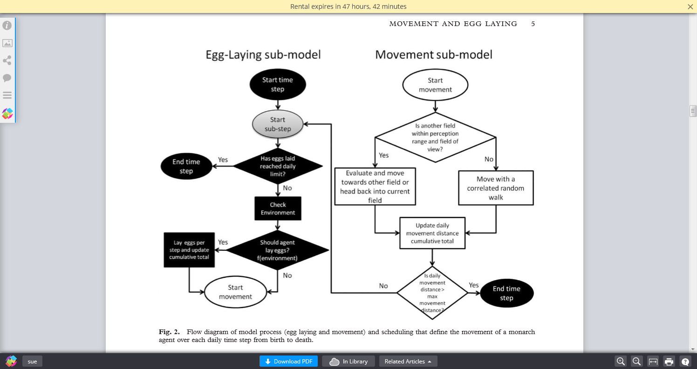

**Sources**

Zalucki, M. P. (1981). The effects of age and weather on egg laying in Danaus plexippus L.(Lepidoptera: Danaidae). Researches on Population Ecology, 23(2), 318-327.

Zalucki, M. P., & Kitching, R. L. (1982a). Dynamics of oviposition in Danaus plexippus (Insecta: Lepidoptera) on milkweed, Asclepias spp. Journal of Zoology, 198(1), 103-116.

Zalucki, M. P., & Kitching, R. L. (1982b). The analysis and description of movement in adult Danaus plexippus L.(Lepidoptera: Danainae). Behaviour, 80(3), 174-197.

Zalucki, M. P., & Kitching, R. L. (1985). The dynamics of adult Danaus plexippus L. around patches of its host plant Asclepias spp. J. Lepid. Soc, 38, 209-19. (***correct year is 1984***)

Zalucki, M. P., Daglish, G., Firempong, S., & Twine, P. (1986). The biology and ecology of Heliothis-armigera (Hubner) and Heliothis-Punctigera Wallengren (Lepidoptera, Noctuidae) in Australia-what do we know. Australian Journal of Zoology, 34(6), 779-814. (***Zalucki et al. 2015 list different authors, were they thinking of a different paper? Author list matches Zalucki et al. 1994 paper on the same species***)

**Model Issues or Potential Improvements**

9/30/2015

1. Probability of laying eggs and the preference value for movement between habitats appear to be confounded.
2. According to Table 2 in the paper, “matrix” habitat had a preference value of 0 or 0.01, but then how does the Monarch ever choose to move into the matrix?
3. Perception is composed of 2 parts, visual and olfactory. Olfactory perception distance may be much greater than visual perception distance.
4. Experiments could be devised to test some of the movement parameters, e.g., releasing Monarchs at some distance from a milkweed patch and observing direction of flight
5. Some insight on movement parameters could be derived from Tori’s data, though it was not specifically designed to measure these parameters
6. Royce and Teresa egg/milkweed data can be used to determine preference values for ROW MW.
7. Egg-laying rate could be potentially less than 20 eggs per 50 m (1 egg per 2.5 m) because they instinctually lay a few eggs and move on
8. The best way to simulate CRP if we can’t get any help on spatial arrangement would be to take low quality farmland (low NCCPI) and add in the known acres of CRP in worst farmland first. CRP will not be randomly distributed in the county.
9. When I asked Hazel Parry (the modeler in Australia) what she thought needed to be improved in the model, she said that the behavior of the butterfly when it decides to stay in a current patch could use some work. The paper says it searches 180 degrees when it returns to a patch or stays in a patch. I would think it would just basically bounce off the patch it didn’t like at the same angle it approached it.
10. Railroad ROW have some excellent habitat in some places and it might be worth surveying those.
11. We could put a distribution on parameters instead of a single number if we thought it varied. For example, number of eggs per day could follow a normal distribution where it starts low, peaks, then drops again.
12. Habitat preference values could vary across the season because of nectar sources or other reasons.
13. Distance moved per day declines rather drastically by the last day, may need adjustment.